Champaign Health District

22
Annual Financial Report
(Unaudited)
Gabe Jones, MPH

MANAGEMENT’S DISCUSSION AND ANALYSIS 4
Highlights 4
Using the Basic Financial Statements 4
Report Components 4
Basis of Accounting 5
Reporting the Health District as a Whole 5
Reporting the District’s Most Significant Funds 6
The Health District as a Whole 6
Table 1 Net Assets 6
Table 2 Change In Net Assets 7
Governmental Activities 9
Table 3 Net Cost of Services 10
The Health District’s Funds 10
General Fund Budgeting Highlights 11
Capital Assets 11
Debt 11
Current Issues 11
Contacting the Health District’s Financial Management 12
Basic Financial Statements 13
Statement of Net Assets – Cash Basis 13
Statement of Activities – Cash Basis 14
Statement of Cash Basis Assets and Fund Balances 15
Statement of Cash Receipts, Disbursements, and Changes in Cash Basis Fund Balances – 16
Statement of Receipts, Disbursements, and Changes 16
General Revenue Fund 18
Statement of Receipts, Disbursements, and Changes 19
Notes to the Financial Statements 19
1. REPORTING ENTITY 20
A. Primary Government 20
B. Component Units 20
2. SUMMARY OF SIGNIFICANT ACCOUNTING POLICIES 20
A. Basis of Presentation 20
B. Fund Accounting 21
C. Basis of Accounting 22
D. Budgetary Process 22
E. Cash and Investments 23
F. Restricted Assets 23
G. Inventory and Prepaid Items 23
H. Capital Assets 23
I. Interfund Receivables/Payables 23
J. Accumulated Leave 23
K. Employer Contributions to Cost-Sharing Pension Plans 23
L. Long-Term Obligations 23
M. Fund Balance Reserves 23
N. Interfund Transactions 24
3. Budgetary Basis of Accounting 24
4. Intergovernmental and Levy Funding 25
5. RISK MANAGEMENT 25
A. Commercial Insurance 25
B. Risk Pool Membership 25
C. County Commissioner Association of Ohio Workers’ Compensation Group Rating Plan 27
D. Employee Medical Benefits 27
6. DEFINED BENEFIT PENSION PLANS 27
7. Post Employment Benefits 28
A. Ohio Public Employees Retirement System 28
8. CONTINGENT LIABILITIES 29
9. CONTRACTUAL OBLIGATIONS 29

MANAGEMENT’S DISCUSSION AND ANALYSIS
  - FOR THE YEAR ENDED DECEMBER 31, 2022 (Unaudited)

This discussion and analysis of the Champaign Health District’s financial performance provides an overall review of the Health District’s financial activities for the year ended December 31, 2022.

, within the limitations of the Health District’s cash basis of accounting. The intent of this discussion and analysis is to look at the Health District’s financial performance as a whole. Readers should also review the basic financial statements and notes to enhance their understanding of the Health District’s financial performance.

Highlights

Key highlights for 2022 are as follows:

- Net assets from all governmental activities increased by $45,213.

- Program specific receipts in the form of charges for services, operating grants and contributions, and contract services comprise the largest percentage of the Health District’s receipts, making up over 60 percent of all the dollars coming into the District.

- The Health District had $1,514,744 in disbursements during 2022.

- The Health District had $1,550,255 in receipts during 2022.

Using the Basic Financial Statements

This annual report is presented in a format consistent with the presentation requirements of Governmental Accounting Standards Board Statement No. 34, as applicable to the Health District’s cash basis of accounting.

Report Components

The statement of net assets and the statement of activities provide information about the cash activities of the Health District as a whole.

Fund financial statements provide a greater level of detail. Funds are created and maintained on the financial records of the Health District as a way to segregate money whose use is restricted to a particular specified purpose. These statements present financial information by fund, presenting funds with the largest balances or most activity in separate columns.

The notes to the financial statements are an integral part of the government-wide and fund financial statements and provide expanded explanation and detail regarding the information reported in the statements.

Basis of Accounting

The basis of accounting is a set of guidelines that determine when financial events are recorded. The Health District has elected to present its financial statements on a cash basis of accounting. This basis of accounting is a basis of accounting other than the generally accepted accounting principles. Under the Health District’s cash basis of accounting, receipts and disbursements are recorded when cash is received or paid.

As a result of using the cash basis of accounting, certain assets and their related revenues (such as accounts receivable) and certain liabilities and their related expenses (such as accounts payable) are not recorded in the financial statements. Therefore, when reviewing the financial information and discussion within this report, the reader must keep in mind the limitations resulting from the use of the cash basis of accounting.

Reporting the Health District as a Whole

The Champaign Health District is established to exercise the rights, privileges, and responsibilities conveyed to it by the constitution and laws of the State of Ohio. The Health District is directed by a five-member Board of Health that appoints a Health Commissioner as its Executive Officer. The Health District’s services include communicable disease investigations, immunization clinics, inspections, public health nursing services, vital statistics, and the issuance of health-related licenses and permits. The Health District also acts upon various complaints made by the public concerning the health and welfare of the county.

The statement of net assets and the statement of activities reflect how the Health District did financially during 2018 within the limitations of cash basis accounting. The statement of net assets presents the cash balances of the governmental activities of the Health District at year-end. The statement of activities compares cash disbursements with program receipts for each governmental program. Program receipts include charges paid by the recipient of the program’s services, and grants and contributions restricted to meeting the operational requirements of a particular program. General receipts are all receipts not classified as program receipts. The comparison of cash disbursements with program receipts identifies how each governmental function draws from the Health District’s general receipts.

These statements report the Health District’s cash position and the changes in cash position. Keeping in mind the limitations of the cash basis of accounting, you can think of these changes as one way to measure the Health District’s financial health. Over time, increases or decreases in the Health District’s cash position is one indicator of whether the Health District’s financial health is improving or deteriorating.

When evaluating the Health District’s financial condition, you should also consider other non-financial factors. Such as, the extent of the Health District’s debt obligations, the reliance on non-local financial resources for operations, and the need for continued growth in in-side millage as a local revenue source.

In the statement of net assets and the statement of activities, all Health District activities are reported as governmental. State and federal grants, fees, and inside millage finance most of these activities. Benefits provided through governmental activities are not necessarily paid for by the people receiving them; particularly in the personal health services division. The Health District has no business-type activities.

Reporting the District’s Most Significant Funds

Fund financial statements provide detailed information about the Health District’s major funds – not the Health District as a whole. The Health District establishes separate funds to better manage its many activities and to help demonstrate that restricted funds are being spent for the intended purpose.

All of the Health District’s activities are reported in Governmental funds. The Governmental fund financial statements provide a detailed view of the Health District’s governmental operations and the basic services it provides. Governmental fund information helps determine whether there are more or less financial resources that can be spent to finance the Health District’s programs. The Health District’s significant Governmental funds are presented on the financial statements in separate columns.

The information for non-major funds (funds whose activity or balances are not large enough to warrant separate reporting) is combined and presented in total in a single column. The Health District’s major Governmental funds are the General Fund and the WIC Fund. The programs reported in Governmental funds are closely related to those reported in the Governmental Activities section of the entity-wide statements.

The Health District as a Whole

Table 1 Net Assets provides a summary of the Health District’s net assets for 2022 on a cash basis. A comparative analysis will be presented.

(Table 1)
Net Assets
 | Governmental Activities
 | 2022 |  | 2021
Assets
Cash and Cash Equivalents | $1,035,173 |  | $1,037,818
Total Assets | $1,441,416 |  | $1,396,203
Net Position
Restricted for:
Other Purposes | $406,243 |  | $358,385
Unrestricted | $1,035,173 |  | $1,037,818
Total Net Assets | $1,441,416 |  | $1,396,203

As mentioned previously, net assets of all governmental activities increased by $45,213 during 2022. The primary reasons contributing to the decreases in cash balances are as follows:

- Increased fees for services due to COVID-19 pandemic workload lessening
- Reimbursement for COVID-19-related activities

Table 2 Change In Net Assets reflects the changes in net position in 2022. A comparative analysis of District-wide data is presented.

(Table 2)
Changes in Net Position
 |  | Governmental
 |  | Activities
 |  | 2022 |  | 2021
Receipts:
Program Receipts:
Charges for Services and Sales |  | 537460 |  | 422282
Contract services |  | 0 |  | 0
Operating Grants and Contributions |  | 531094 |  | 520683
Total Program Receipts |  | 1068554 |  | 942965
General Receipts:
Revenue from Subdivisions |  | 168,500 |  | 168,500
State Subsidy |  | 23504 |  | 15087
Levy |  | 289698 | 286927
Other
Total General Receipts |  | 481702 |  | 470514
Total Receipts |  | 1550256 |  | 1413479
Disbursements:
Environmental Health
Food Program |  | 99534 |  | 86043
Solid Waste |  | 4655 |  | 4594
Swimming Pools |  | 3036 |  | 3068
Camps |  | 0 |  | 0
Plumbing |  | 78461 |  | 76176
Sewage |  | 66812 |  | 56094
Other Environmental Health |  | 104076 |  | 101045
Personal Health Services |  | 64512 |  | 62633
Immunizations |  | 50509 |  | 49445
Laboratory |  | 13419 |  | 14430
Grants
WIC |  | 157355 |  | 175447
GVO |  | 17034 |  | 13122
Public Health Emergency |  | 79799 |  | 76661
Preparedness |  | 79799  0 |  | 76661  0
Zika
COVID | 617591 |  | 617591
Vital Statistics |  | 24792 |  | 23541
Child Abuse Prevention |  | 11929 |  | 11367
Administration |  | 581789 |  | 71750
Travel/Training |  | 11945 |  | 9299
County Auditor/Treasurer Fee |  | 10419 |  | 5860
Rent/Maintenance Phones |  | 40416 |  | 41992
Other Health Expenditures |  | 18771 |  | 0
Total Disbursements |  | 1514744 |  | 1500158
Increase (Decrease) in Net Position | $45213 |  | $(83688)
Net Position, January 1 |  | $1396203 |  | $1477513
Net Position, December 31 |  | $1441416 |  | $1396203

General receipts represent 31 percent of the Health District’s total receipts, and of this amount, 35 percent are local taxes (revenue from subdivisions) provided by each municipality and District in the county. Levy dollars represent 60 percent of general receipts, with the remaining amount at less than 5 percent provided by the State Subsidy.

Disbursements for the Health District represent the overhead costs of running the Health District and the support services provided for the other District activities. These include primarily the costs of personnel and personnel support at 74 percent of total disbursements, as the primary product of the Health District is preventive health services which are labor-intensive.

Capital outlay signifies the disbursements for equipment for use in administering the Health District’s services. There were no significant equipment purchases during 2022, with the total equipment purchases at less than 3 percent of all disbursements.

Governmental Activities

If you look at the Statement of Activities on the next page, you will see that the first column lists the major services provided by the Health District. The next column identifies the costs of providing these services. The major program disbursements for governmental activities are for Public Health services.

The Net Cost (Disbursement) column compares the program receipts to the cost of the service. This “net cost” amount represents the cost of the service that ends up being paid from money provided by local taxpayers. These net costs are paid from the general receipts that are presented at the bottom of the Statement. A comparison between the total cost of services and the net cost is presented in Table 3. All grants (IAP, WIC, and Public Health Emergency Preparedness) have a zero net cost to the health district, in 2008 all grant funds were separated from one general fund; any apparent net costs to the district are not real and should be attributed to changes in accounting practices, carryover, and differing fiscal years.

Table 3 Net Cost of Services

 | Cash |  |  | Net Cost
 | Disbursements |  |  | of Services
Governmental Activities
Environmental Health
Food Program | 99,534 |  |  | (32,107)
Solid Waste | 4,655 |  |  | (762)
Swimming Pools | 3,036 |  |  | (681)
Camps | 0 |  |  | 634
Plumbing | 78,461 |  |  | (18,116)
Sewage | 65,812 |  |  | (12,327)
Other Environmental Health | 104,076 |  |  | (70,811)
Personal Health Services | 64,512 |  |  | (50,792)
Immunizations | 50,509 |  |  | 12,648
Laboratory | 13,419 |  |  | (3,629)
Grants
WIC | 157,355 |  |  | 453
GVO | 17,034 |  |  | (8,992)
COVID Supplies/Equipment | 69,766 |  |  | 56,806
Public Health Emergency | 79,799 |  |  | 41,552
Vital Statistics | 24,792 |  |  | 22,969
Child Abuse Prevention | 11,929 |  |  | (404)
Administration | 581,789 |  |  | (581,789)
Travel/Training | 11,945 |  |  | (11,945)
County Auditor/Treasurer Fee | 10,419 |  |  | (10,419)
Rent/Maintenance/Phones | 40,416 |  |  | (40,416)
Other Health | 18,771 |  |  | 268,656
Total Governmental Activities | 1,514,744 |  |  | (439,473)

The Health District’s Funds

Total Governmental funds had receipts of $1,550,256 and disbursements of $1,514,744. In the Environmental Health Division, most of the services are provided for a fee based on current cost methodologies. However, even with adjustments to fees during 2022 the division is not self-funded and requires monies from the general fund. In the Nursing and Personal Health Services division, most of the services provided are not fee based and are primarily funded via the general fund.
General Fund Budgeting Highlights

The Health District’s budget is prepared according to Ohio law and is based upon accounting for certain transactions on a basis of cash receipts, disbursements, and encumbrances. The most significant budgeted fund is the General Fund.

During 2022, the Health District amended its General and Special Revenue fund budgets to reflect changing circumstances.

Revenues for the General Fund were originally budgeted at $821,940 and actual revenue was $1,124,370.

Disbursements for the General Fund were originally budgeted at $944,500 and actual disbursements were $1,075,590.

Capital Assets

The Health District does not currently keep track of its capital assets and infrastructure. The Health District has not made plans to track this, as it is not required by current law. The Health District does not own land or other real estate at this time.

Debt

As of December 31, 2022, the Health District’s outstanding debt included future lease payments for the office facility and copier equipment, as well as accumulated leave balances for the Health District’s employees. For further information regarding the Health District’s rental lease, refer to the note 10 to the basic financial statements.

Current Issues
The challenge for all Health Districts is to provide high quality preventive health services to the public while staying within the restrictions imposed by limited, and in some cases shrinking funding. The Health District relies heavily on inside millage from the cities, townships, and villages and state levy grant funds; as the inside millage and the grant funds are fairly fixed, we continue to struggle with the increases in operating expenses primarily in personnel costs. Without a significant change in these resources, even with conservative spending, the Health District will continue to see a decrease in financial stability. The District successfully passed a 0.4 mil levy in November 2007, May 2012, November 2016, and November 2021. This additional funding in 2023 through 2028 will assure that basic service provision can continue even with shrinkage of grant funding.

Contacting the Health District’s Financial Management

This financial report is designed to provide our citizens, taxpayers, investors, and creditors with a general overview of the Health District’s finances and to reflect the Health District’s accountability for the monies it receives. Questions concerning any of the information in this report or requests for additional information should be directed to Gabe Jones, Health Commissioner, Champaign Health District, 1512 S. US Highway 68, Suite Q100, Urbana, OH 43078.

Basic Financial Statements

Statement of Net Assets – Cash Basis
For the Year Ending December 31, 2022
(Unaudited)

 | Primary Government
 | Governmental
 | Activities
Assets
Equity in Pooled Cash and Cash Equivalents | 1,441,416
Total Position | 1,441,416
Net Assets
Restricted for:
Other Purposes | 406,243
Unrestricted | 1,035,173
Total Net Position | 1,441,416
See accompanying notes to the basic financial statements

Statement of Activities – Cash Basis
For the Year Ended December 31, 2022
(Unaudited)

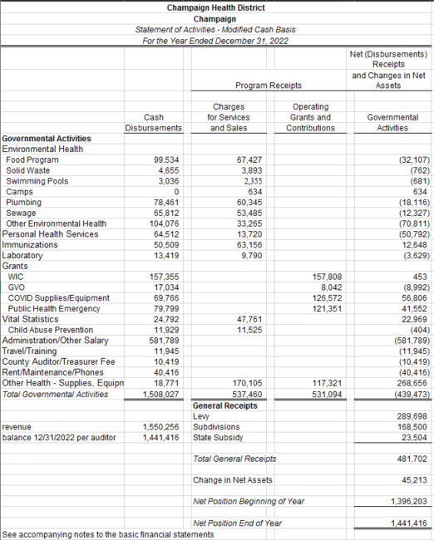

Statement of Cash Basis Assets and Fund Balances

For the Year Ending December 31, 2022
(Unaudited)

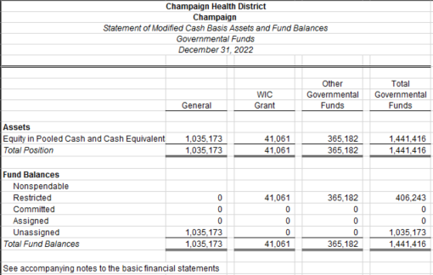

Statement of Cash Receipts, Disbursements, and Changes in Cash Basis Fund Balances –
For the Year Ending December 31, 2022
(Unaudited)

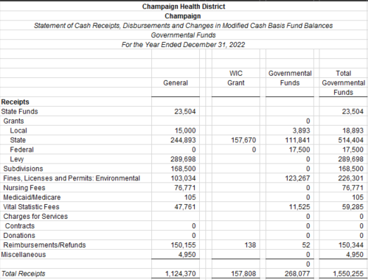

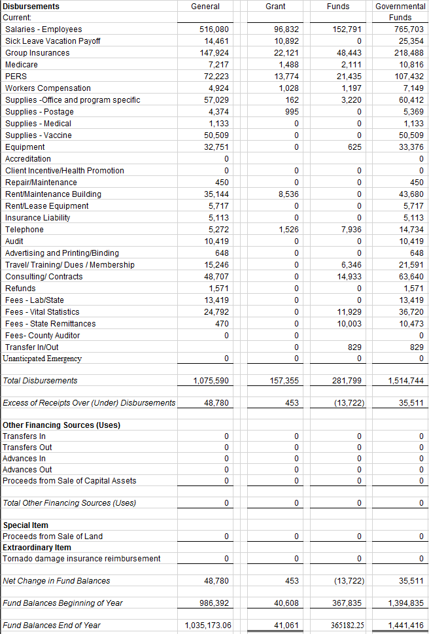

Statement of Receipts, Disbursements

General Revenue Fund
For the Year Ending December 31, 2022
(Unaudited)
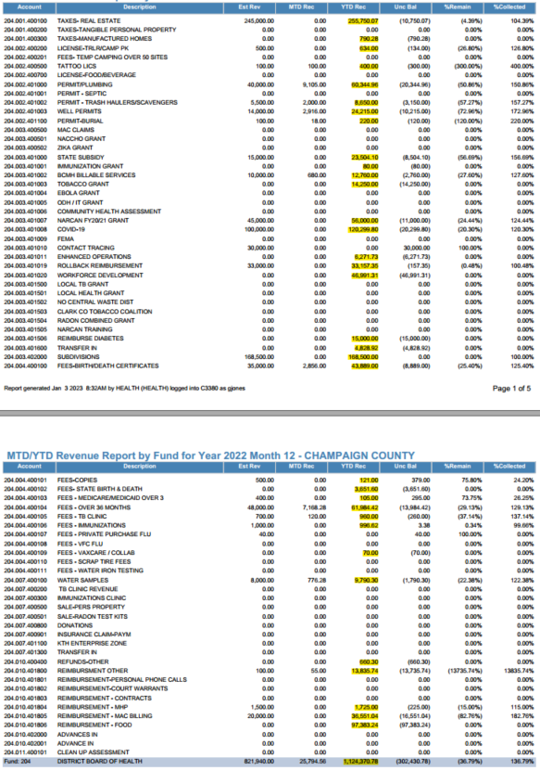
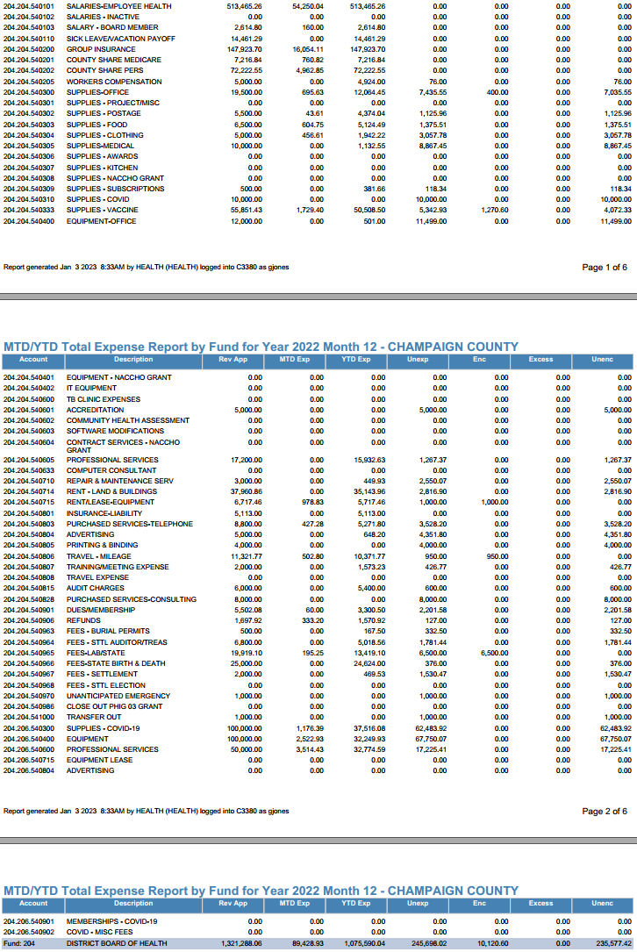
Notes to the Financial Statements
  - FOR THE YEAR ENDED DECEMBER 31, 2022 (Unaudited)

1. REPORTING ENTITY

The constitution and laws of the State of Ohio establish the rights and privileges of the Champaign Health District, (the Health District) as a body corporate and politic.

A five-member Board of Health appointed by the District Advisory Council governs the Health District. The Board appoints a health commissioner and all employees of the Health District.

The reporting entity is composed of the primary government, component units, and other organizations that are included to ensure the financial statements of the Health District are not misleading.

A. Primary Government

The primary government consists of all funds, departments, boards and agencies that are not legally separate from the Health District. The Health District’s services include vital statistics, prevention and control of disease, immunization clinics, public health nursing services, inspections, the issuance of health-related licenses and permits, sanitation, abatement and removal of nuisances, and emergency response planning.

B. Component Units

Component units are legally separate organizations for which the Health District is financially accountable. The Health District is financially accountable for an organization if the Health District appoints a voting majority of the organization’s governing board and (1) the Health District is able to significantly influence the programs or services performed or provided by the organization; or (2) the Health District is legally entitled to or can otherwise access the organization’s resources; or the Health District is legally obligated or has otherwise assumed the responsibility to finance the deficits of, or provide support to, the organization. Component units also include legally separate, tax-exempt entities whose resources are for the direct benefit of the Health District, are accessible to the Health District and are significant in amount to the Health District. The Health District includes no component units.

The Health District’s management believes these financial statements present all activities for which the District is financially responsible.

2. SUMMARY OF SIGNIFICANT ACCOUNTING POLICIES

As discussed further in Note 2.C, these financial statements are presented on a cash basis of accounting. This cash basis of accounting differs from accounting principles generally accepted in the United States of America (GAAP). Generally accepted accounting principles include all relevant Governmental Accounting Standards Board (GASB) pronouncements, which have been applied to the extent they are applicable to the cash basis of accounting. Following are the more significant of the Health District’s accounting policies.

A. Basis of Presentation

The Health District’s basic financial statements consist of government-wide financial statements, including a statement of net assets and a statement of activities, and fund financial statements which provide a more detailed level of financial information.

1. Government-Wide Financial Statements

The statement of net assets and the statement of activities display information about the Health District as a whole. These statements include the financial activities of the primary government. These statements usually distinguish between those activities of the Health District that are governmental in nature and those that are considered business-type activities. Governmental activities generally are financed through taxes, intergovernmental receipts or other non-exchange transactions. Business-type activities are financed in whole or in part by fees charged to external parties for goods or services. The Health District has no business-type activities.

The statement of net assets presents the cash balance of the governmental activities of the Health District at year end. The statement of activities compares disbursements and program receipts for each program or function of the Health District’s governmental activities. Disbursements are reported by function. A function is a group of related activities designed to accomplish a major service or regulatory program for which the Health District is responsible. Program receipts include charges paid by the recipient of the goods or services offered by the program, grants and contributions that are restricted to meeting the operational or capital requirements of a particular program and contract services rendered for a program. Receipts which are not classified as program receipts are presented as general receipts of the Health District, with certain limited exceptions. The comparison of direct disbursements with program receipts identifies the extent to which each governmental program is self-financing on a cash basis or draws from the general receipts of the Health District.

2. Fund Financial Statements

During the year, the Health District segregates transactions related to certain Health District functions or activities in separate funds in order to aid financial management and to demonstrate legal compliance. Fund financial statements are designed to present financial information of the Health District at this more detailed level. The focus of governmental fund financial statements is on major funds. Each major fund is presented in a separate column. Non-major funds are aggregated and presented in a single column.

B. Fund Accounting

The Health District uses funds to maintain its financial records during the year. A fund is defined as a fiscal and accounting entity with a self-balancing set of accounts. Funds are used to segregate resources that are restricted as to use. All of the funds of the Health District are governmental.

1. Governmental Funds

Governmental funds are those through which most governmental functions of the Health District are financed. The following are the Health District’s major governmental funds:

The General Fund accounts for all financial resources, except those required to be accounted for in another fund. The General Fund balance is available to the Health District for any purpose provided it is expended or transferred according to the general laws of Ohio.

The Public Health Emergency Preparedness Grant Fund, the Immunization Action Plan Grant Fund, and the WIC Grant Fund account for State and Federal grant money used to provide programs in Champaign County. The WIC funds are predominantly for early childhood issues including nutrition, early detection and intervention. The Public Health Emergency Preparedness Fund includes the Public Health Emergency Preparedness and Medical Reserve Corps funds, which are used to provide public health emergency preparedness and volunteer recruitment activities for the county. The Immunization Action Plan fund is used to provide immunization and immunization education for families of children birth through thirty five months. Each of these funds is restricted for a particular purpose.

The other governmental funds of the Health District account for grants and other resources whose use is restricted for a particular purpose.

C. Basis of Accounting

The Health District’s financial statements are prepared using the modified cash basis of accounting. Receipts are recorded in the Health District’s financial records and reported in the financial statements when cash is received rather than when earned and disbursements are recorded when cash is paid rather than when a liability is incurred.

As a result of the use of this modified cash basis of accounting, certain assets and their related revenues (such as accounts receivable and revenue for billed or provided services not yet collected) and certain liabilities and their related expenses (such as accounts payable and expenses for goods or services received but not yet paid, and accrued liabilities and their related expenses) are not recorded in these financial statements.

D. Budgetary Process

All funds, except agency funds, are legally required to be budgeted and appropriated. The major documents prepared are the tax budget, the certificate of estimated resources, and the appropriations resolution, all of which are prepared on the budgetary basis of accounting. The tax budget demonstrates a need for existing or increased tax rates. The certificate of estimated resources establishes a limit on the amount the Board of Health may appropriate. The appropriations resolution is the Board of Health’s authorization to spend resources and sets annual limits on cash disbursements plus encumbrances at the level of control selected by the Board of Health. The legal level of control has been established by the Board of Health at the fund, function, and object level for all funds.

ORC Section 5705.28(C)(1) requires the Health District to file an estimate of contemplated revenue and expenses with the municipalities and Health Districts within the Health District by about June 1 (forty-five days prior to July 15). The county auditor cannot allocate property taxes from the municipalities and Health Districts within the district if the filing has not been made.

ORC Section 3709.28 establishes budgetary requirements for the Health District, which are similar to ORC Chapter 5705 budgetary requirements. On or about the first Monday of April the Health District must adopt an itemized appropriation measure. The appropriation measure, together with an itemized estimate of revenues to be collected during the next fiscal year, shall be certified to the county budget commission. Subject to estimated resources, the Board of Health may, by resolution, transfer appropriations from one appropriation item to another, reduce or increase any item, create new items, and make additional appropriations or reduce the total appropriation. Such appropriation modifications shall be certified to the county budget commission for approval.

The amounts reported as the original budgeted amounts on the budgetary statements reflect the amounts on the certificate of estimated resources in effect when the original appropriations were adopted. The amounts reported as the final budgeted amounts on the budgetary statements reflect the amounts on the amended certificate of estimated resources in effect at the time final appropriations were passed by the Board of Health.

The appropriations resolution is subject to amendment throughout the year with the restriction that appropriations cannot exceed estimated resources. The amounts reported as the original budget reflect the first appropriation resolution that covered the entire year, including amounts automatically carried forward from prior years. The amount reported as the final budgeted amounts represents the final appropriations passed by the Board of Health during the year.

E. Cash and Investments

The Champaign County Treasurer is the custodian for the Health District’s cash and investments. The County’s cash and investment pool holds the Health District’s cash and investments, which are reported at the County Treasurer’s carrying amount. Deposits and investments disclosures for the County as a whole may be obtained from the Champaign County Auditor, 1512 S. US Highway 68, Suite B300, Urbana, Ohio 43078, (937) 484-1555.

F. Restricted Assets

Assets are reported as restricted when limitations on their use change the nature or normal understanding of the availability of the asset. Such constraints are either externally imposed by creditors, contributors, grantors, or laws of other governments, or are imposed by law through constitutional provisions or enabling legislation.

G. Inventory and Prepaid Items

The Health District reports disbursements for inventory and prepaid items when paid. These items are not reflected as assets in the accompanying financial statements.

H. Capital Assets

Acquisitions of property, plant and equipment are recorded as disbursements when paid. These items are not reflected as assets in the accompanying financial statements.

I. Interfund Receivables/Payables

The Health District reports advances-in and advances-out for interfund loans. These items are not reflected as assets and liabilities in the accompanying financial statements.

J. Accumulated Leave

In certain circumstances, such as upon leaving employment or retirement, employees are entitled to cash payments for unused leave. Unpaid leave is not reflected as a liability under the Health District’s cash basis of accounting.

K. Employer Contributions to Cost-Sharing Pension Plans

The Health District recognizes the disbursement for employer contributions to cost-sharing pension plans when they are paid. As described in Notes 7 and 8, the employer contributions include portions for pension benefits and for postretirement health care benefits.

L. Long-Term Obligations

The Health District’s cash basis financial statements do not report liabilities for long-term obligations. Proceeds of debt are reported when the cash is received and principal and interest payments are reported when paid. Since recording a capital asset when entering into a capital lease is not the result of a cash transaction, neither another financing source nor capital outlay expenditure is reported at inception. Lease payments are reported when paid.

M. Fund Balance Reserves

Fund balance is divided into five classifications based primarily on the extent to which the Health District is bound to observe constraints imposed upon the use of the resources in the governmental funds. The classifications are as follows:

Nonspendable The nonspendable fund balance category includes amounts that cannot be spent because they are not in spendable form, or are legally or contractually required to be maintained intact. The “not in spendable form” criterion includes items that are not expected to be converted to cash. It also includes the long-term amount of interfund loans.

Restricted Fund balance is reported as restricted when constraints placed on the use of resources are either externally imposed by creditors (such as through debt covenants), grantors, contributors, or laws or regulations of other governments; or is imposed by law through constitutional provisions.

Committed The committed fund balance classification includes amounts that can be used only for the specific purposes imposed by formal action (resolution) of the Board of Health. Those committed amounts cannot be used for any other purpose unless the Board of Health removes or changes the specified use by taking the same type of action (resolution) it employed to previously commit those amounts. In contrast to fund balance that is restricted by enabling legislation, the committed fund balance classification may be redeployed for other purposes with appropriate due process. Constraints imposed on the use of committed amounts are imposed by the Board of Health, separate from the authorization to raise the underlying revenue; therefore, compliance with these constraints is not considered to be legally enforceable. Committed fund balance also incorporates contractual obligations to the extent that existing resources in the fund have been specifically committed for use in satisfying those contractual requirements.

Assigned Amounts in the assigned fund balance classification are intended to be used by the Health District for specific purposes but do not meet the criteria to be classified as restricted or committed. In governmental funds other than the general fund, assigned fund balance represents the remaining amount that is not restricted or committed. In the general fund, assigned amounts represent intended uses established by the Board of Health or a Health District official delegated that authority by resolution, or by State Statute.

Unassigned Unassigned fund balance is the residual classification for the general fund and includes amounts not contained in the other classifications. In other governmental funds, the unassigned classification is used only to report a deficit balance.

The Health District applies restricted resources first when expenditures are incurred for purposes for which either restricted or unrestricted (committed, assigned, and unassigned) amounts are available. Similarly, within unrestricted fund balance, committed amounts are reduced first followed by assigned, and then unassigned amounts when expenditures are incurred for purposes for which amounts in any of the unrestricted fund balance classifications could be used.

N. Interfund Transactions

Exchange transactions between funds are reported as receipts in the seller funds and as disbursements in the purchaser funds. Subsidies from one fund to another without a requirement for repayment are reported as interfund transfers. Interfund transfers are reported as other financing sources/uses in governmental funds. Repayments from funds responsible for particular cash disbursements to the funds that initially paid for them are not presented in the financial statements.

3. Budgetary Basis of Accounting

The budgetary basis as provided by law is based upon accounting for certain transactions on the basis of cash receipts, disbursements, and encumbrances. The Statement of Receipts, Disbursements and Changes in Fund Balance – Budget and Actual – Budgetary Basis presented for the general fund and each major special revenue fund is prepared on the budgetary basis to provide a meaningful comparison of actual results with the budget. The difference between the budgetary basis and the cash basis is outstanding year end encumbrances are treated as expenditures (budgetary basis) rather than as a reservation of fund balance (cash basis) and outstanding year end advances are treated as an other financing source or use (budgetary basis) rather than as an interfund receivable or payable (cash basis). The encumbrances outstanding at year end (budgetary basis) amounted to:

General Fund | $0
Major Special Revenue Funds:
WIC | $0
Other Governmental Funds | $0
Child Abuse and Neglect, PHEP, Food, and Sewage
Total | $0

4. Intergovernmental and Levy Funding

The County apportions the excess of the Health District’s appropriations over other estimated receipts among the Districts and municipalities composing the District, based on their taxable property valuations. The County withholds the apportioned excess from property tax settlements and distributes it to the District. The financial statements present these amounts as Subdivision revenue.

5. RISK MANAGEMENT

A. Commercial Insurance

The Health District has obtained commercial insurance for the following risks:

- Employee health insurance
- Errors and omissions.

B. Risk Pool Membership

The Champaign Health District is exposed to various risks of property and casualty losses, and injuries to employees.

The Champaign Health District belongs to the Public Entities Pool of Ohio (PEP), a risk-sharing pool available to Ohio local governments. PEP provides property and casualty coverage for its members. York Risk Pooling Services, Inc. (YORK), functions as the administrator of PEP and provides underwriting, claims loss control, risk management, and reinsurance services for PEP. PEP is a member of American Public Entity Excess Pool (APEEP), which is also administered by YORK. Member governments pay annual contributions to fund PEP. PEP pays judgments, settlements and other expenses resulting from covered claims that exceed the members’ deductibles.

C. Casualty and Property Coverage

Casualty and Property Coverage
APEEP provides PEP with an excess risk-sharing program. Under this arrangement, PEP retains insured risks up to an amount specified in the contracts. At December 31, 2017, PEP retained $350,000 casualty claims and $100,000 for property claims.

The aforementioned casualty and property reinsurance agreements do not discharge PEP’s primary liability for claims payments on covered losses. Claims exceeding coverage limits are the obligation of the respective PEP member.

Financial Position
PEP’s financial statements (audited by other accountants) conform with generally accepted accounting principles, and reported the following assets, liabilities and retained earnings at December 31, 2021 and 2020 (the latest information available):

 | 2021 | 2020
Assets | $41,996,850 | $40,318,971
Liabilities | (14,974,099) | (14,111,510)
Net Assets – Unrestricted | $27,022,751 | $26,207,461

The assets above include approximately $11.3 million and $11.5 million of unpaid claims to be billed to approximately 527 member governments in the future, as of December 31, 2017 and 2016, respectively. These amounts will be included in future contributions from members when the related claims are due for payment.
Based on discussions with PEP, the expected rates PEP charges to compute member contributions, which are used to pay claims as they become due, are not expected to change significantly from those used to determine the historical contributions detailed below. By contract, the annual liability of each member is limited to the amount financial contributions required to be made to PEP for each year of membership.

Contributions to PEP
2019 | 2017
3902 | 3840

The Champaign Health District’s actual contributions for 2019 and 2017 in table above.

After one year of membership, a member may withdraw on the anniversary of the date of joining PEP, if the member notifies PEP in writing (via certified mail) 60 days prior to the anniversary date. Upon withdrawal, members are eligible for a full or partial refund of their capital contributions, minus the subsequent year’s contribution. Withdrawing members have no other future obligation to PEP. Also upon withdrawal, payments for all casualty claims and claim expense become the sole responsibility of the withdrawing member, regardless of whether a claim occurred or was reported prior to the withdrawal.

C. County Commissioner Association of Ohio Workers’ Compensation Group Rating Plan

For 2021, the Health District, through Champaign County as their fiscal agent, participated in the State of Ohio Worker’s Compensation system. The Health District budgets 4.5% of wages to provide Workers’ Compensation coverage for its’ employees; this amount will remain the same for 2022.

D. Employee Medical Benefits

The Health District participates in a health insurance plan through Anthem available for all fulltime employees. The fully insured plan includes health, mental health and prescription benefits.

The cost of the program for 2021 was $173,172 compared to $126,980 in 2019.

6. DEFINED BENEFIT PENSION PLANS

The Health District participates in the Ohio Public Employees Retirement System (OPERS). OPERS administers three separate pension plans. The traditional plan is a cost-sharing, multiple-employer defined benefit pension plan. The member-directed plan is a defined contribution plan in which the member invests both member and employer contributions (employer contributions vest over five years at 20 percent per year). Under the member-directed plan, members accumulate retirement assets equal to the value of the member and vested employer contributions plus any investment earnings.

The combined plan is a cost-sharing, multiple-employer defined benefit pension plan that has elements of both a defined benefit and a defined contribution plan. Under the combined plan, employer contributions are invested by the retirement system to provide a formula retirement benefit similar to in nature to, but less than, the traditional plan benefit. Member contributions, whose investment is self-directed by the member, accumulate retirement assets in a manner similar to the member-directed plan.

OPERS provides retirement, disability, survivor and death benefits and annual cost-of-living adjustments to members of the traditional and combined plans. Members of the member-directed plan do not qualify for ancillary benefits. Authority to establish and amend benefits is provided by Chapter 145 of the Ohio Revised Code. OPERS issues a stand-alone financial report that may be obtained by writing to OPERS, 277 East Town Street, Columbus, OH 43215-4642 or by calling (614) 222-5601 or (800) 222-7377.

Funding Policy – The Ohio Revised Code provides statutory authority for member and employer contributions and currently limits the employer contribution to a rate not to exceed 14 percent of covered payroll for state and local employer units and 18.1 percent of covered payroll for law and public safety employer units. Member contribution rates, as set in the Ohio Revised Code, are not to exceed 10 percent. For the year ended December 31, 2013, members in state and local classifications contributed 10 percent of covered payroll while public safety and law enforcement members contributed 12 percent and 12.6 percent, respectively. While members in the state and local divisions may participate in all three plans, law enforcement and public safety divisions exist only within the Traditional Pension Plan. For 2013, member and employer contribution rates were consistent across all three plans. Effective January 1, 2014, the member contribution rates for law enforcement members increased to 13.0 percent.

The Health District’s contribution rate was 14.0 percent, except for those plan members in law enforcement or public safety, for whom the contribution was 18.1 percent of covered payroll. The portion of employer contributions used to fund pension benefits is net of post-employment health care benefits. The portion of employer contribution allocated to health care for members in all three plans was 1 percent for 2013. Employer contribution rates are actuarially determined.

The Health District’s required contributions for pension obligations to the traditional and combined plans for the years ended December 31, 2019, 2018, 2017, were $84,172, $79,538, and $77,081, respectively. The full amount has been contributed for 2019, 2018, and 2017.

7. Post Employment Benefits

A. Ohio Public Employees Retirement System

Ohio Public Employees Retirement System (OPERS) administers three separate pension plans: The Traditional Pension Plan—a cost sharing, multiple-employer defined benefit pension plan; the Member-Directed Plan—a defined contribution plan; and the Combined Plan—a cost sharing, multiple employer defined benefit pension plan that has elements of both a defined benefit and defined contribution plan.

OPERS maintains a cost-sharing multiple-employer defined benefit post-employment health care plan for qualifying members of both the Traditional Pension and the Combined Plans. Members of the Member-Directed Plan do not qualify for ancillary benefits, including post-employment health care coverage. The plan includes a medical plan, prescription drug program and Medicare Part B premium reimbursement.

In order to qualify for post-employment health care coverage, age-and-service retirees under the Traditional Pension and Combined Plans must have 10 or more years of qualifying Ohio service credit. Health care coverage for disability benefit recipients and qualified survivor benefit recipients is available. The Ohio Revised Code permits, but does not mandate, OPERS to provide health care benefits to its eligible members and beneficiaries. Authority to establish and amend benefits is provided in Chapter 145 of the Ohio Revised Code.

Disclosures for the health care plan are presented separately in the OPERS financial report which may be obtained by writing to OPERS, 277 East Town Street, Columbus, Ohio 43215-4642, or by calling 614-222-5601 or 800-222-7377.

Funding Policy – The post-employment health care plan was established under, and is administrated in accordance with, Internal Revenue Code 401(h). The Ohio Revised Code provides the statutory authority requiring public employers to fund post-retirement health care through contributions to OPERS. A portion of each employer’s contribution to OPERS is set aside for the funding of post-retirement health care.

Employer contribution rates are expressed as a percentage of the covered payroll of active members. In 2013, state and local employers contributed at a rate of 14.0 percent of covered payroll, and public safety and law enforcement employers contributed at 18.1 percent. The Ohio Revised Code currently limits the employer contribution to a rate not to exceed 14 percent of covered payroll for state and local employer units and 18.1 percent of covered payroll for law and public safety employer units.

Each year, the OPERS Retirement Board determines the portion of the employer contribution rate that will be set aside for funding of post-employment health care benefits. The portion of employer contributions allocated to health care for members in the Traditional Plan was 1% in 2013. The portion of employer contributions allocated to health care for members in the Combined Plan was 1% in 2013. Effective January 1, 2014, the portion allocated to healthcare was raised to 2 percent for both plans, as recommended by the OPERS actuary.

The OPERS Retirement Board is also authorized to establish rules for the payment of a portion of the health care benefits provided, by the retiree or their surviving beneficiaries. Payment amounts vary depending on the number of covered dependents and the coverage selected. Active members do not make contributions to the post-employment health care plan.

The Health Care Preservation Plan (HCPP) adopted by the OPERS Retirement Board on September 9, 2004, was effective January 1, 2007. Member and employer contribution rates increased on January 1 of each year from 2006 to 2008. Rates for law and public safety employers increased over a six year period beginning on January 1, 2006, with a final rate increase on January 1, 2011. These rate increases allowed additional funds to be allocated to the health care plan.

Changes to the healthcare plan were adopted by the OPERS Board of Trustees on September 19, 2012, with a transition plan commencing January 1, 2014. With the recent passage of pension legislation under SB 343 and the approved healthcare changes, OPERS expects to be able to consistently allocate 4 percent of the employer contributions towards the health care fund after the end of the transition period.

8. CONTINGENT LIABILITIES

Amounts grantor agencies pay to the Health District are subject to audit and adjustment by the grantor, principally the federal government. Grantors may require refunding any disallowed costs. Management cannot presently determine amounts grantors may disallow. However, based on prior experience, management believes any refunds would be immaterial.

9. CONTRACTUAL OBLIGATIONS

The Health District is a party to a multi-year lease for rental of office space. This lease will be renewed in January 2023. This lease requires the District to remit monthly.

